**Student Name: Weight: Contributes to 10% Engagement Mark**

**Student ID:** **Marks:** **Pass/Fail/Award**

# Group Exercise: Using Subqueries

## Equipment and Materials

For this lab, you will need:

* A Windows computer with a minimum of 16GB RAM and 250GB of free disk space, capable of nested virtualization
* Access to ORACLE SQL*PLUS
* The following data provided on Brightspace:
  + JustLeeDatabase.zip

## Instructions

1. First, work through steps 2-4 individually. Then arrange a time to come together with your small group. As a group, create one solution based on the best individual solutions for each problem. Further refine the solution as a group as needed.
2. Review the JustLee Bookstore database and physical model.
3. Review the Problem Set, Tips for Success, and Marking Criteria sections of this document.
4. Write a single script that answers all the questions in the problem set.
5. Lowercase Romain numerals (i,ii,iii) indicate possible intermediate steps for questions in the problem set. Please do **not** include the code for the intermediate steps. The intermediate steps are provided to assist in problem solving. The intermediate steps are a roadmap showing one way that you could solve the problem.
6. Only one submission is required per group. The submission should include:
   1. One script file
   2. One spool file showing all results
   3. One attribution list that outlines the activities, time spent and resources associated with completing this assignment. An example attribution list is provided on Brightspace under Course Resources.

## Problem Set

1. Which customers ordered the same books as customers in Texas? Show the book title, state and customer #.
2. Below is the expected result.

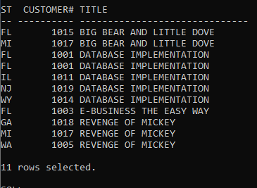

1. You could take the following intermediate steps to reach the resultant table above.
2. Get a list of books ordered by customers in Texas.

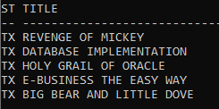

1. Find all customers that have ordered those books and are not in Texas.
2. Which books have been ordered in the greatest number of different states? List the titles and the states in which the books have been ordered. Notice there are two books that have been ordered by customers in five states.
3. Below is the expected result.

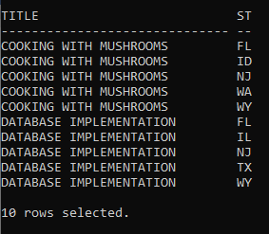

1. You could take the following intermediate steps to reach the resultant table above.
2. Here is a unique list of ISBN and the number of times they have been ordered.

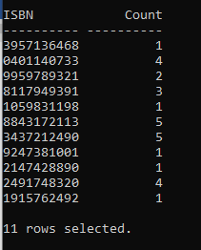

1. What is the largest number of different states a book has been ordered in?

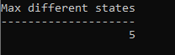

1. Which books will the shipping department have to distribute to the most states?
2. What book was ordered the most based on its quantity in orderitems?
3. Below is the expected result.

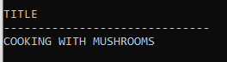

1. You could take the following intermediate steps to reach the resultant table above.
2. Start with a list of all books and the quantity that has been ordered.

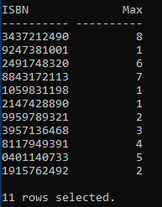

1. What is the largest quantity count from that list of books?

Shows result of eight.

1. Find all books with a count equal to the maximum.
2. What was the most recent book ordered in each category and when was it ordered?
3. Below is the expected output result.

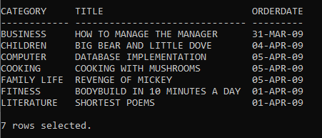

1. You could take the following intermediate steps to reach the resultant table above.
2. Create a list of categories, books and order dates. You end up with multiple books in each category.

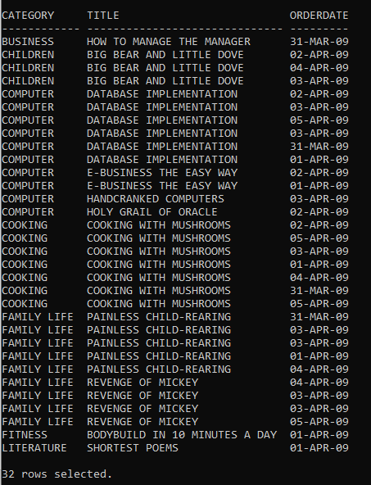

1. Create a set (category, orderdate) where the order date is the newest (largest) for each category.

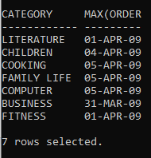

1. Find books that are represented by the categories and order dates within this value set.

## Marking Criteria

You must pass all categories to pass the activity.

|  |  |  |  |
| --- | --- | --- | --- |
| **Categories** | **Fail** | **Pass** | **Score** |
| Submission provided | No | Yes | **Pass/Fail** |
| Attribution List Provided | No | Yes | **Pass/Fail** |
| Reasonable attempt to solve each question | No | Yes | **Pass/Fail** |
| Spool File with commands included | No | Yes | **Pass/Fail** |
| **Pass/Fail** | | | |